**Program 12: Demonstrate create, concatenation, membership and iteration operation on a tuple**

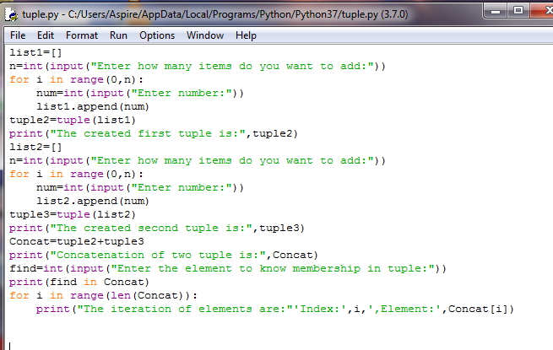

**Output:**

